After Action Report

Hackathon: February 20, 2025
Breann Larson

Development Expression for Assigning IDs

Problem
When assigning IDs for each layer, finding the correct expression when calculating this field takes time. The long list of different expressions is confusing to navigate and lengthens the process. On top of these issues, every pStart Value is different. In some instances, you include the 1 or 0, and other times you do not.

Tools Used
At the beginning of this effort, we did some pseudo-coding, which allowed us to identify 2 important factors when rewriting this expression.
  - Select the Base or Prefix (AVV, GV, SS, etc.)
  - Select the Last Used ID # + 1.
To accomplish this, we used portions of the existing codes for a new universal code, as well as ChatGPT to help with making sure that the syntax was correct. Theo and Chris also assisted in this effort, they provided insight and code knowledge.

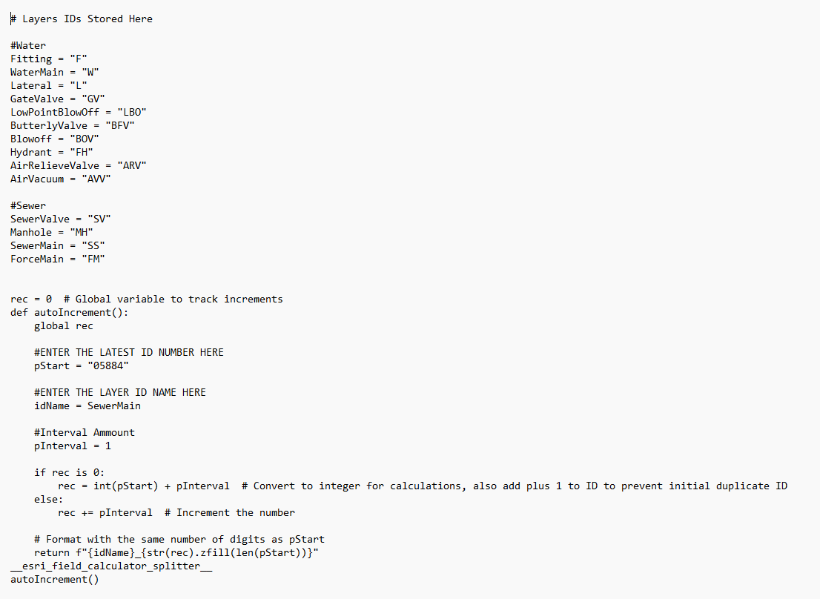
Solution

The universal code that we were able to create will cut the time that it usually takes us to fish out the correct expression to use in half. This realistically would only be saving a couple of minutes; however, the new universal code contains all the water and sewer prefixes in one place. This will ultimately cause a greater sense of familiarity as to which expression to use and greater accessibility.
There is less confusion when trying to understand which number is correct with or without the 0. We believe that this new change in expression will cause fewer ID numbers to be repeated/duplicated.

Code for Checking Map Projection, Location, Layers, Parcel Accuracy

Problem
Upon the need to implement new standards for As-built submissions, checks for correct map projections, inclusion of all layers, and accurate location need to be integrated into the workflow. To minimize time and be more efficient, codes for: checking the correct map projection of all layers, ensuring that all layers are within the GDB, and that the location is accurate should be implemented. Criteria for these checks include comparing the parcel polygon with Douglas County, CO polygons with a 95% - 100% parcel overlap, if the correct layers exist with the correct naming conventions, and if the correct fields are present with correct labeling conventions and datatype.

Tools Used
Chris and Theo used ArcPro Notebook, which is where we started our code blocks during this time. This was helpful in editing the syntax and understanding code errors. ChatGPT was utilized to check our code for any formatting issues with the syntax.

Solution
During this time, we started on a code block to check the Map Projection, along with formatting the output to be more readable. This code included entering the path and checking the path to the GDB for the As-Built submission. The code checked every layer to ensure it is in NAD 1983 (2011) StatePlane Colorado Central FIPS 0502 (US Feet). If the incorrect spatial reference is used, a return in red displaying the layer name and the incorrect spatial reference is displayed, and if correct, the layer name is displayed in green. Work on solving the checks for parcel overlap, as well as checking if the correct fields still exist, needs to be done.

Overall Takeaways and Reflection
Breann
My overall takeaway from the Geohackathon was that our workflow can be streamlined with coding. Along with streamlining our daily workflows, it saves us time and ultimately reduces inaccuracy in our datasets. The Geohackathon was a great way to refresh some of my minor coding experience. It helped me build a new frame of thinking and how to approach solving problems.

